**Unit 3**

**AIRCRAFT PROPULSION**

**Introduction**

During the initial stages of aircraft development, people were trying to build their own aircrafts by just studying the flying characteristics of birds and insects. This was because, at that time, there were no aircrafts or helicopters present and the only creatures capable of flying were the birds and insects. And also it's a well-known fact that, human beings were totally fascinated by the birds and always had a strong desire to fly like them. So people used to always gaze at birds and insects to understand how they fly, glide, turn, etc and also to gather information regarding their flying characteristics.

In the beginning, people thought that apart from ***weight, lift*** was the only force required to make an aircraft airborne. By considering the lift and weight forces, people had designed different types of aircrafts which mostly looked like birds or insects and were desperately trying to fly. But to their disappointment, as soon as the aircraft was taking off, it came down heavily to the ground causing serious injuries and damages to the person as well as the aircraft.

After a series of unsuccessful flights, people realised that there was one more force in disguise, which was always preventing the aircraft to move forward and they named that force as the ***drag*** force. Now they had a fair idea of the lift, weight and the drag forces acting on an aircraft. By considering all these forces, aircraft enthusiasts tried to redesign and rebuild their aircrafts and tried to launch it. But again it resulted in utter failure and eventually in a catastrophic destruction. Many people also lost their lives while attempting to fly. At this juncture, most of them stopped experimenting with their lives and aircrafts and started to thoroughly analyse their design in detail. After a detailed analysis, they made two important discoveries which turned out to be a landmark moment in the history of aviation.

1. When an aircraft is moving, the drag and the weight of the aircraft will be continuously acting on the aircraft. i.e., the drag and weight will not be acting intermittently but act continuously thought out the flight envelope. So in order to overcome these negative forces, there should be a continuous supply of forward force to the aircraft.
2. All the failures which had previously occurred were not primarily due to inefficient aerodynamic design but due to insufficient source of power available to sustain forward flight. This means that people had a fairly good knowledge about aerodynamics and its importance. Wind tunnels were also invented and used to study the aerodynamics of airfoils and wings.

So these were the prime reasons for which an aircraft was unable to fly and achieve a sustained flight. Once scientists and engineers got to know that this was the prime reason behind all the failures, they started to scout for various methods by which a continuous forward motion can be provided to the aircraft and this is how engines were being introduced on every aircraft that was designed. Finally, this improvisation paved way for a new engineering vertical called ***Aircraft******Propulsion*** which totally changed the future of Aviation Industry.

This period of scouting for engines had exactly occurred during the Industrial revolution which witnessed tremendous inventions in various fields of engineering. One such invention was the steam engine which was developed for powering various industries. Later on Internal Combustion engines were invented which were the direct descendants of the steam engines. With this, the reciprocating engines became the first breed of engines to be used as propelling devices for aircrafts.

In 1903, Wright brothers used an in-line engine, a type of reciprocating engines on their Wright flyer. With the aid of this engine they could fly their plane for nearly 120feet and with this the Wright flyer became the first successful heavier-than-air aircraft to achieve sustained flight for almost 12 seconds and it was a watershed moment, which no one had previously achieved in the history of aviation industry. The success of Wright flyer marked the beginning of a new era in the aviation industry after which there was no looking back at all.

Right from the period of Wright Brothers till the culmination of World war II (a period spanning for almost 40 years), IC engines were extensively used to power all the aircrafts irrespective of commercial aircraft or military aircraft. Even to this day, piston engine aircrafts remain popular for both personal and business use.

**Classification of Aerospace Power plants**

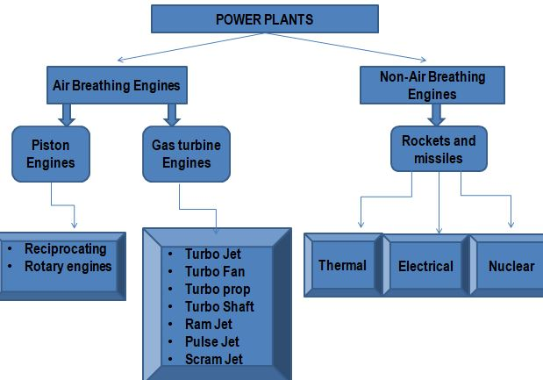

***Fig : Classification of Power plants for Aerospace Applications***

Right from the time of Wright Flyer-I, for the next forty years, piston engines were extensively used to power all the commercial and military aircrafts. Later due to the increased demand for air travel, and continuously increasing military dominance, attention was shifted towards the development of high capacity passenger aircrafts and high performance military aircrafts. As the aircraft technologies evolved, I C engines became too inefficient to support these high performance aircrafts because of the following disadvantages:

1. Suitable only for small sized aircrafts
2. Inefficient at higher altitude
3. Increased vibrational problems
4. Lubrication problems
5. Cooling problems
6. Increased frontal area
7. Increased drag
8. Increased fuel consumption
9. Increased complexities in design

In order to overcome the above said disadvantages, attention was shifted towards the development of high performance ***gas turbine engines*** which were much simpler and lighter in construction than the I C engines. Since then gas turbine engines have been designed, tested and tried on various aircrafts. Till date gas turbines are the most widely used source of power for aircraft propulsion.

**GAS TURBINE ENGINES**

The Brayton cycle was proposed by George Brayton in 1870 for use in reciprocating engines. Gas turbines operate in open-cycle mode, but can be modelled as closed cycle using air-standard assumptions. The two major application areas of gas-turbine engines are aircraft propulsion and electric power generation. Gas turbines used for aircraft applications are always open cycle, which means that fresh air is enters the compressor at the end of each cycle.

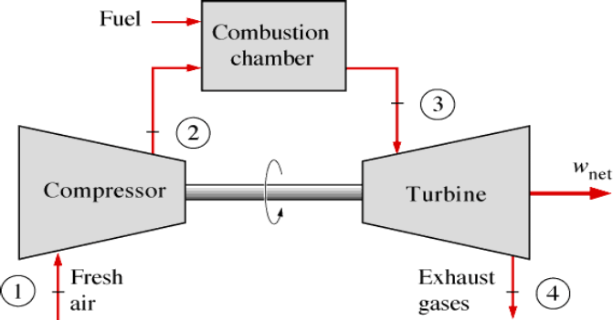

***Fig : Simple Gas Turbine Engine***

A simple gas turbine engine which works on Brayton Cycle is essentially a constant pressure cycle. Brayton cycle consists of four thermodynamic processes viz. two isentropic processes and two constant pressure processes. A simple gas turbine engine can be realized with three major components and they are

1. Compressor
2. Combustion Chamber
3. Turbine

The various thermodynamic processes that occur in any gas turbine engine are

* Isentropic Compression
* Constant Pressure Heat Addition
* Isentropic Expansion
* Constant Pressure Heat Rejection

During the working of any gas turbine engine, air from the atmosphere will be drawn into the compressor wherein the air is compressed isentropically. In doing so, the pressure of the air is increases and is represented by the curve 1-2 on the P-V diagram. The high pressure air form the compressor will be passed to the combustion chamber. In the combustion chamber the high pressure air will be mixed thoroughly with the fuel and ignited. Due to the ignition process, the combustible mixture will undergo combustion at a constant pressure resulting in the generation of high pressure and high temperature exhaust gases and is represented by curve 2-3. Further, this high pressure and temperature exhaust gases will be supplied to the turbine unit, wherein the exhaust gases will be expanded isentropically. As the exhaust gases pass through the turbine, they turn the turbine blades and in turn the shaft producing useful work. In doing so, the pressure and the temperature of the exhaust gases will reduce and is given by the curve 3-4 on the P-V diagram. Finally, the exhaust gases will be exhausted to the atmosphere where the pressure of the exhaust gases will become atmospheric and is given by the curve 4-1 on the P-V diagram.

In any gas turbine engine, the compressor will always be coupled to a turbine. Here, both compressor and turbine are prime movers, which help in the process of energy transfer and energy transformation. A compressor is similar to an electric fan, which requires energy from an external source to operate, whereas, a turbine is like a wind mill/turbine, which generates its own energy and provides energy for other components to operate. In any gas turbine engine, a compressor will always draw energy which is generated by the turbine. Hence, it is always necessary for a turbine to produce enough power so that it can drive the compressor and other auxiliary components.

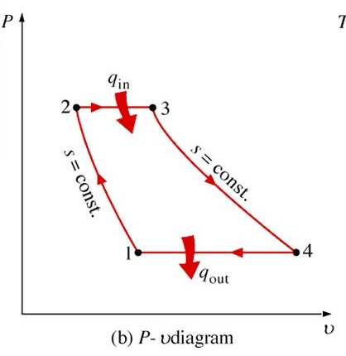 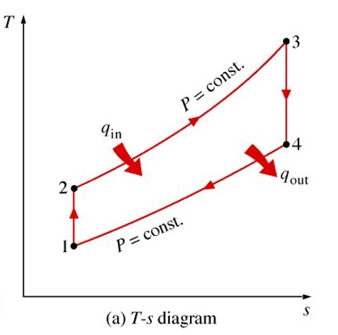

***Fig : P-v and T-s Diagrams of a simple gas turbine engine***

**DEVIATIONS OF BRAYTON CYCLE FROM IDEAL CONDITIONS**

Like in any other gas power cycle, even in a Brayton cycle, there are some percentages of losses which cause the cycle to deviate from the ideal case. The actual/real gas-turbine cycle differs from the ideal Brayton cycle on several accounts and the deviation is evident in all the various process in the cycle.

**Assumptions considered in Brayton cycle:**

1. There are no frictional losses throughout the cycle.
2. There are no irreversibilities occurring in the processes.
3. The processes in the diffuser, compressor, turbine and nozzle are assumed to be isentropic.
4. Air is assumed to behave like Ideal gas with specific heats to remain constant throughout the cycle.

**COMPRESSOR**

There are various losses occurring in different components of a gas turbine engine. In a compressor, as the air is passed through the compressor, frictional forces (Mechanical friction + Fluid Friction) will be established between the moving air and the compressor blades itself. Due to fluid friction in the compressor, some amount of kinetic energy is lost and it is irreversibly converted into the internal energy of the fluid. In due course, the entropy of the fluid increases resulting in a non-isentropic flow through the compressor, i.e., compression process is non-isentropic. But in an ideal case, since the frictional forces are neglected, the flow through the compressor is considered to be isentropic as represented by the curve (1-2s) on the T-s diagram. Sometimes, there are high chances of turbulence and possible shock losses which increase the temperature of the working fluid. This results in a higher exit temperature of the working fluid, for a given pressure ratio, higher than ideal case. All these losses occurring in a compressor causes the compressor to absorb more power than required for a given pressure ratio. The non-isentropic compression process is represented by the curve (1-2a). The shallower the positive slope on the T-s diagram, the less efficient will be the compression process.

**COMBUSTION CHAMBER**

Next, the high pressure air from the compressor is admitted into the combustion chamber. In any typical combustion chamber, air and fuel are supplied separately. In order to achieve complete combustion, the reactants (fuel and air) needs to be thoroughly mixed before ignition is initiated. To accomplish a thorough mixing between the fuel and air, turbulence is promoted in the combustion chamber, which causes the velocity of the fluid to slightly increase at the cost of a pressure drop. Also as the working fluid passes through the combustion chamber, due to friction, there will be some unavoidable total pressure losses. Therefore, the heat addition process does not occur at a constant pressure as illustrated by the curve (2a-3), which contradicts the ideal conditions represented by curve (2s-3) on the T-s diagram.

**TURBINE**

Further, the high pressure and high temperature exhaust gases will be passed into the turbine, where the exhaust gases are expanded isentropically in an ideal case. But in a real Brayton cycle, mechanical and fluid friction causes the fluid to decelerate, resulting in dissipating some kinetic energy into internal energy rise, which increases the entropy of the working fluid (Irreversible). As the entropy increases, the process will never be isentropic as illustrated in the ideal cycle. Thus the expansion of the working fluid in a turbine is always non-isentropic. Ideally, this process of isentropic expansion in a turbine is represented by a vertical line (3-4s) on the T-s diagram. But in a real Brayton cycle, due to irreversibilities like friction and turbulence, the pressure drop will be greater and the corresponding temperature drop is represented by the curve (3-4a) on the T-s diagram, which is lesser than the ideal case. The shallower the negative slope on the T-s diagram, the less efficient the expansion process and the turbine will produce less work output.

**NOZZLE**

Finally, the slightly high pressure and temperature exhaust gases are passed on to the exhaust nozzle. Due to fluid friction and turbulence, a total pressure loss will occur across the nozzle and the heat rejection process does not occur at a constant pressure as illustrated by the curve (4a-1), which contradicts the ideal conditions represented by curve (4s-1) on the T-s diagram.

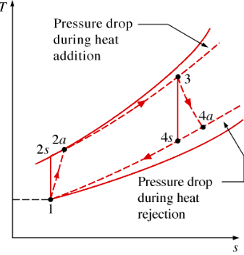

***Fig : Ideal & Real Brayton Cycle***

**CONCLUSION**

The actual gas-turbine cycle is different from the ideal Brayton cycle since there are irreversibilities. Hence, in an actual gas-turbine cycle, the compressor consumes more work and the turbine produces less work than that of the ideal Brayton cycle.

As per Clausius inequality,



If,

, the cycle is irreversible and possible

, the cycle is reversible

, Since it violates II law of thermodynamics, the cycle is impossible

From the principle of Entropy, for any infinite process we have



For an isolated system, since dQ=0, dSisolated0

For a reversible process, dSisolated =0

For an irreversible process, dSisolated >0

A Brayton cycle can be realised using only three components, viz. Compressor, Combustion Chamber and a turbine. But by slightly modifying the Gas turbine engine, various derivatives can be accomplished that may find applications in different types of aircraft.

The various possible configurations of a simple gas turbine engine are

1. Turbojet Engine
2. Turboprop Engine
3. Turbofan Engine
4. Turboshaft Engine
5. Ramjet Engine
6. Scramjet Engine

In an ideal cycle, the power generated in the turbine equals the power consumed in the compressor. Hence the net power output is essentially zero. But whereas in a turbojet propulsion cycle, the gases are expanded in a turbine only upto a certain pressure ratio such that the power produced is enough to drive the compressor and the auxiliary equipment. Further, the exhaust gases with the remaining pressure are finally sent to a nozzle wherein the exhaust gases are accelerated to produce the required thrust.

**TURBOJET ENGINE**

A turbojet engine is the simplest form of a gas turbine engine. The entire engine will be housed in a cylindrical shell like casing which will be attached to the wing or tail in case of a civil airplane and submerged within the fuselage in a military aircraft. The important components of any typical turbojet engine is

* Inlet Diffuser
* Axial Flow Compressor
* Combustion Chamber
* Turbine
* Tailpipe
* Exhaust Nozzle

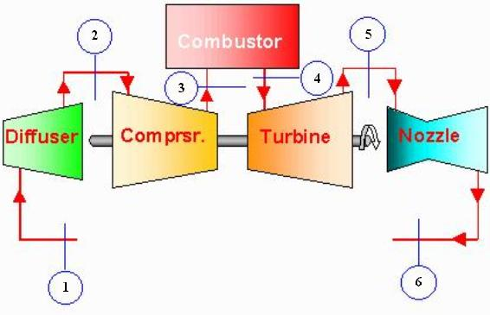 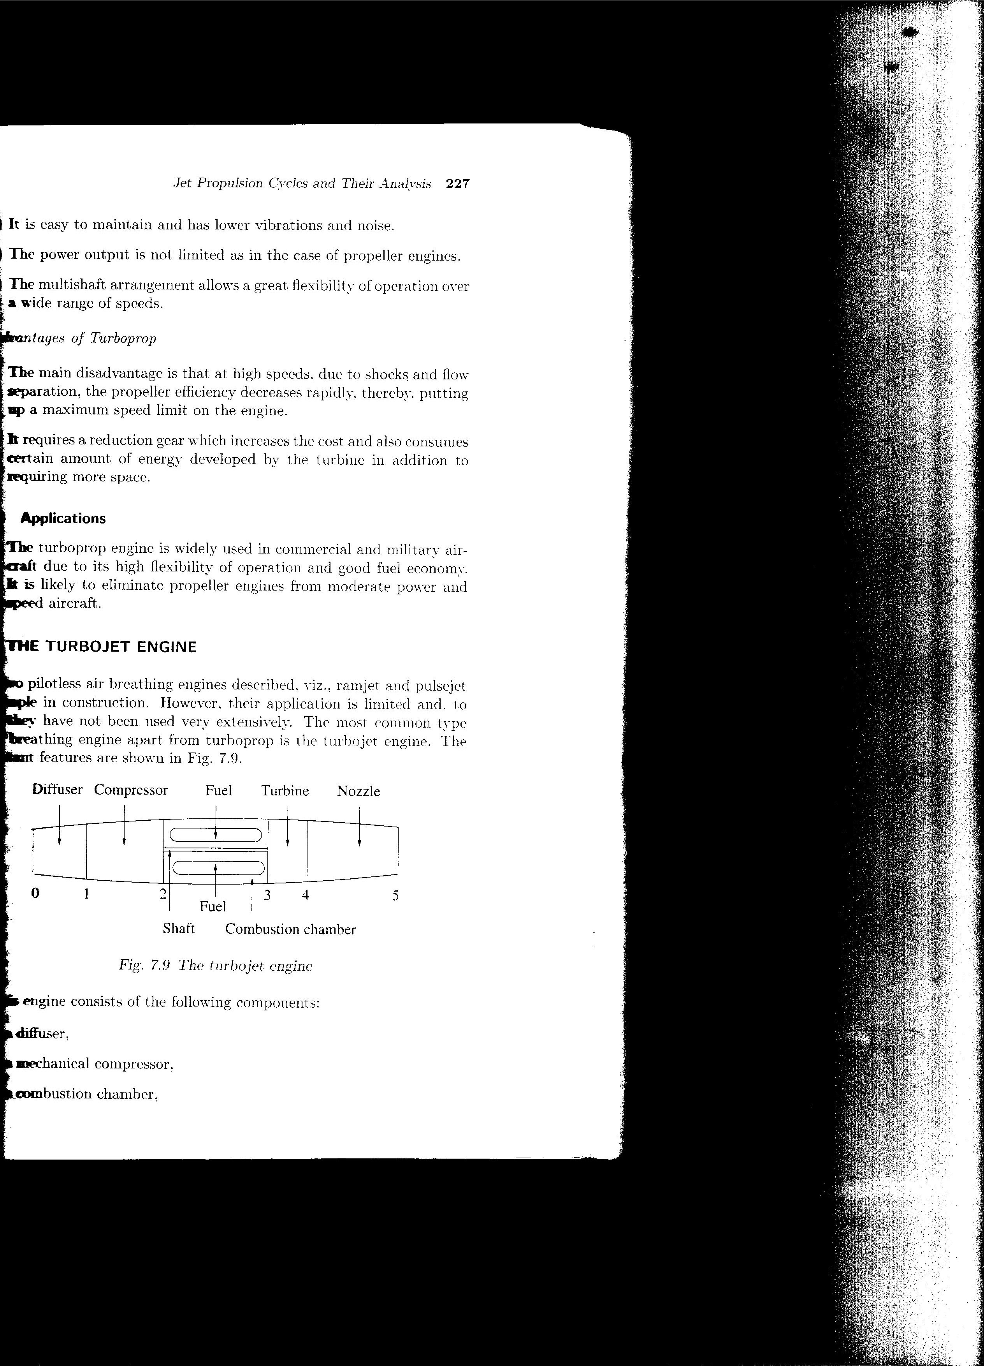

***Fig : Schematic of a single stage Turbojet Engine***

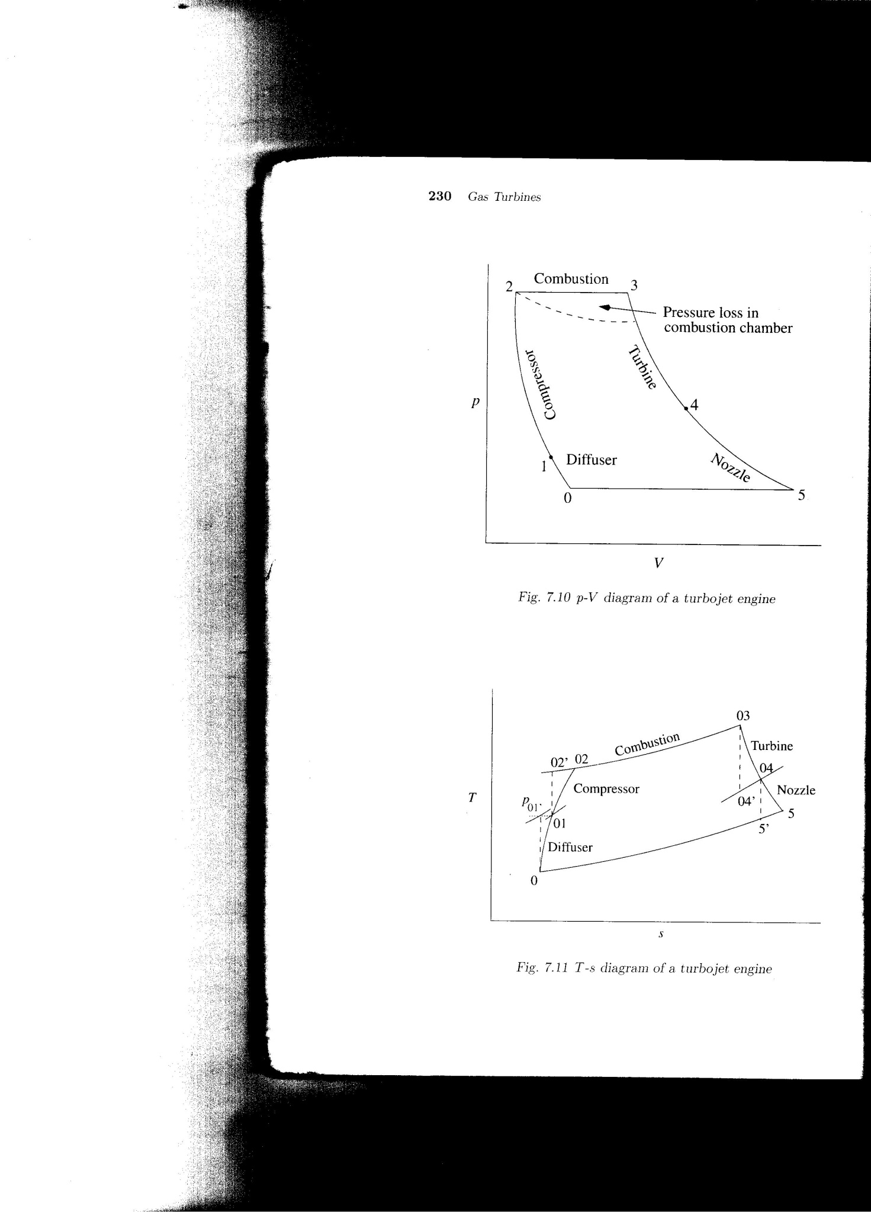 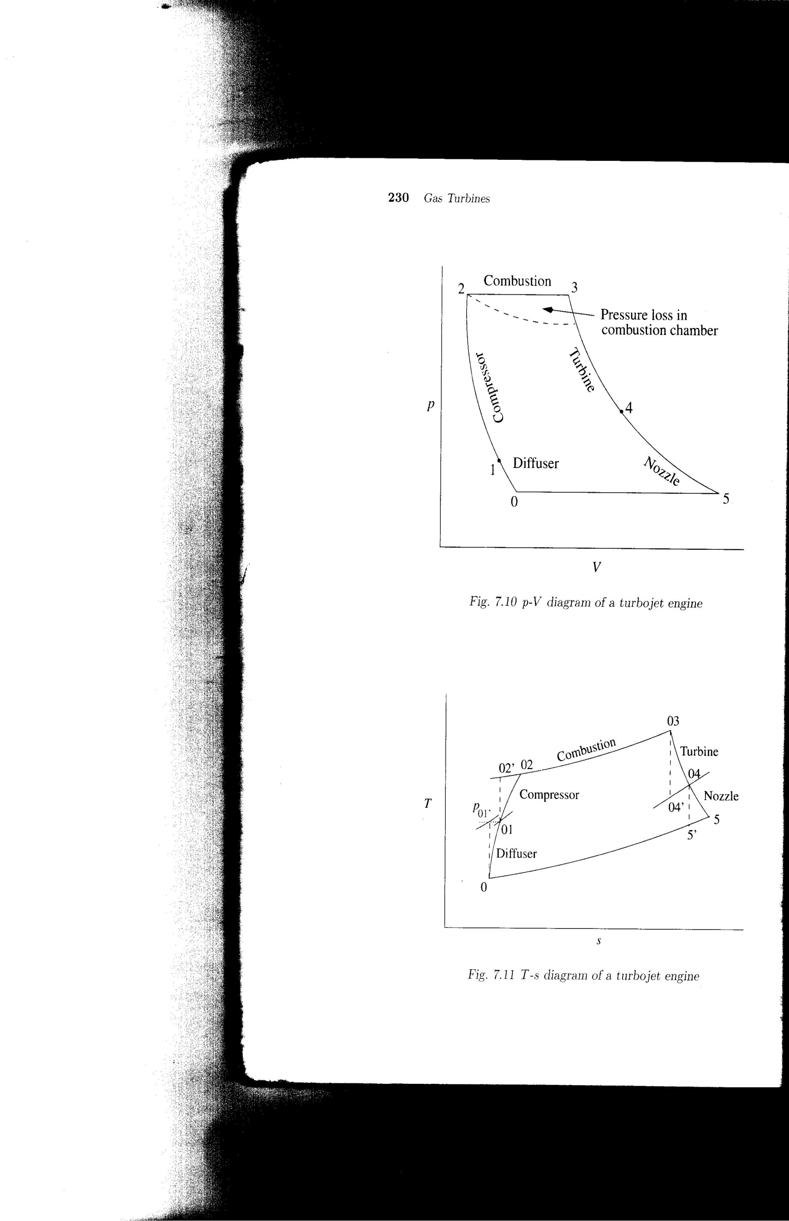

***Fig : P-V and T-s Diagram for a single stage Turbojet Engine***

During the working of a turbojet engine, the air will be drawn to the compressor through the inlet diffuser. The main function of an inlet diffuser is to decrease the kinetic energy of the incoming air and convert it to pressure rise. This is because, when the aircraft is flying at high forward speeds or velocity, even the air entering the engine will be possessing very high velocities. This high velocity air cannot be supplied directly to the compressor, which may affect its performance resulting in compressor stall and surge. So whatever the forward velocity of flight may be, the velocity of air has to be decelerated to the conditions acceptable by the compressor. The ideal velocity conditions required for a compressor is around M=0.3 and this is achieved in a diffuser wherein the kinetic energy of the air is converted into a pressure rise resulting in an slight increase in static pressure in a diffuser itself.

The high pressure air form the diffuser will now be supplied to the compressor wherein the air is compressed to a high pressure in an isentropic manner and represented by the curve 2-3 on the P-V diagram. Along with the pressure, there is also a rise in temperature in the compressor. Later, this high pressure and temperature air will be passed into the combustion chamber, where it gets mixed with the fuel and undergoes combustion at a constant pressure. The process of combustion increases the temperature of the exhaust gases at a constant pressure for a given mass flow rate and is illustrated by the curve 3-4. The temperatures achieved in a typical combustion chamber will be around 2000k. Further, this high temperature and high pressure exhaust gases will be will be passed to the turbine unit, where in the gases are expanded isentropically and represented by the curve 4-5. As the gases pass through the turbine, they rotate the turbine blades and in turn the turbine shaft, thus producing useful work. The power produced by the turbine will be utilized to run the compressor and other accessories. Further, the exhaust gases will be passed to the atmosphere through an exhaust nozzle having a converging cross section, which is exactly opposite to an inlet duct in terms of shape and function. In the exhaust nozzle, the pressure energy of the exhaust gases will be converted into kinetic energy. Finally, the high velocity exhaust gases will blast out of the nozzle at a very high velocity, creating the required forward thrust for the aircraft and thus propelling it forward. An important aspect of a turbojet engine is that, the thrust produced by a turbojet engine is by exhaust gases alone. Hence, the thrust produced by a turbojet engine is always less at sea level.

**Total Thrust = Nozzle Thrust**





**Characteristics of a Turbojet Engine**

1. Low thrust at low forward speeds
2. Relatively high TSFC at low altitudes and speeds
3. Lightest specific weight
4. Ability to take advantage of highest ram pressure
5. Lowest frontal area and almost no ground clearance problem

**Advantages of Turbojet Engine**

* Ideal for long distance flight at higher speeds and altitudes
* Lower frontal area and shorter landing gear
* Lower weight per unit thrust at design speeds and altitude
* Pressure rise through inlet diffuser is significant
* Reheat can be employed for increased thrust

**Disadvantages of Turbojet Engine**

* Take-off roll is longer requiring longer runway
* TSFC is comparatively higher at low speeds and altitudes
* Uneconomical on short distance flights
* Lower thrust and propulsive efficiency at lower speeds.

**TURBOPROP ENGINE**

A turboprop engine is an intermediate of a pure turbojet and a propeller engine. A turboprop is nothing more than a turbojet engine fitted with a standard airplane propeller through a reduction gear mechanism. The reduction gear is added to reduce the rotational speed of the shaft to a value suitable for the propeller. The major components of any typical turboprop engine are

1. Propeller
2. Reduction Gear
3. Compressor
4. Combustion chamber
5. Turbine
6. Nozzle

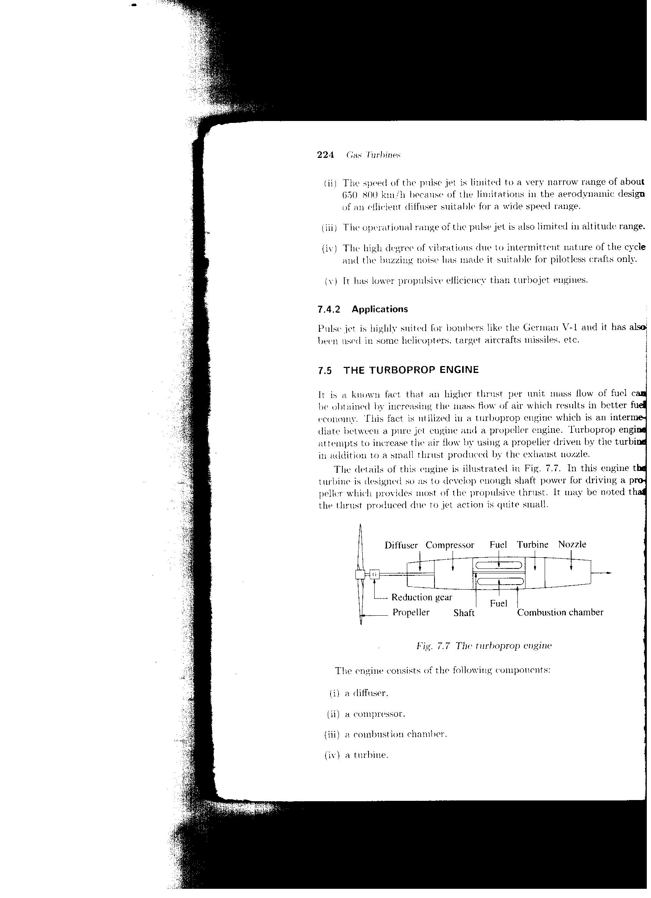 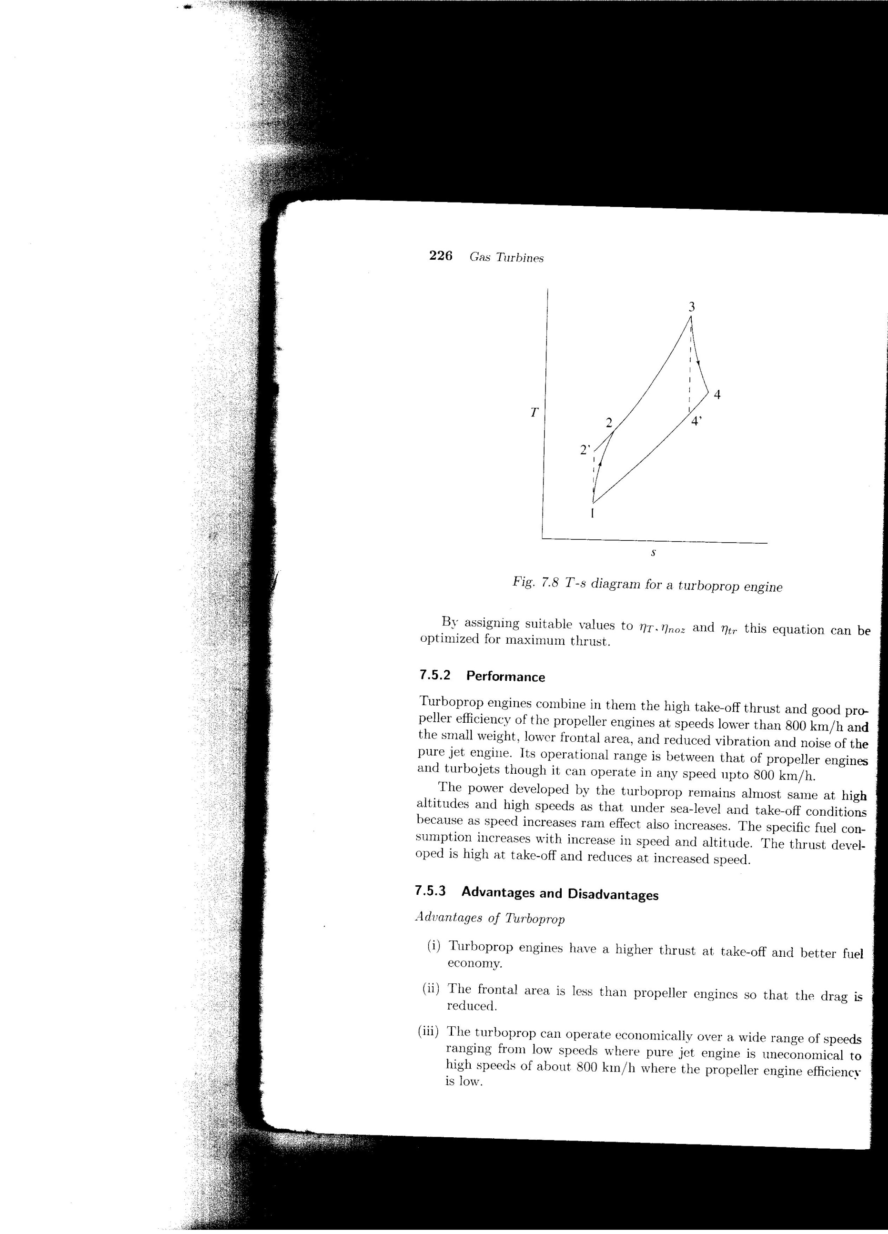

***Fig : Schematic of a single stage turboprop engine & T-s diagram***

The working principle of a turboprop engine is similar to that of a turbojet engine. The atmospheric air is drawn into the diffuser where the kinetic energy of the air is converted into pressure energy, thereby slightly increasing the static pressure of the atmospheric air. This air is then supplied to the compressor where the air is compressed isentropically resulting in a very high pressure air. Increasing the pressure, simultaneously increases the temperature of the air in the compressor. Next, the high pressure air is transferred into the combustion chamber where it is mixed thoroughly with the fuel resulting in a readily combustible mixture. Due to the process of ignition, combustion occurs at a constant pressure giving rise to a huge mass of exhaust gases which are subsequently expanded through a turbine. In a turboprop engine, the turbine generates enough power to drive the propeller, compressor and other auxiliaries.

In a turboprop engine, the thrust produced is due to the momentum flux of air passing through the propeller as well as by the exhaust gases passing through the exhaust nozzle. The thrust generated by exhaust gases represent only about 10% of the total thrust whereas the remaining thrust is developed by the propeller alone. The total thrust generated by a turboprop engine is given by

**Total Thrust = Nozzle Thrust + Propeller Thrust**



The thrust developed by a turboprop engine at sea level is very high due to the availability of large mass of air. But the thrust reduces as the speed and altitude increase. Turboprop engines combine in them the high take-off thrust and good propeller efficiency at speeds lower than 800km/h.

**Characteristics of a Turboprop Engine**

1. Very high propulsive efficiency at low airspeeds but with altitude it falls off rapidly
2. Most complicated design and heavier than turbojet
3. Lowest TSFC
4. Large frontal area, Longer landing gear for low wing airplanes
5. Highly efficient thrust reversals

**Advantages of Turboprop Engine**

* Higher thrust at low speeds
* Take off roll is short
* Propulsive efficiency within operational range is high
* Specific fuel consumption is low
* Thrust reversal is easily achieved

**Disadvantages of Turboprop Engine**

* Application is limited to lower speeds and altitude
* Landing gears have to be longer
* Engine is heavier and complicated
* Usually centrifugal compressors are used which increases the frontal area
* Higher weight per unit thrust

**TURBOFAN ENGINE**

A turbofan engine is essentially a combination of a turboprop and a turbojet engine. A turbofan engine can be realised by incorporating a turbojet in an enclosed duct with a fan located in the front of the engine as shown in the figure.

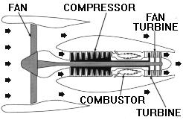

***Fig : Schematic of a single stage turbofan engine***

During the working of a turbofan engine, as the fan rotates it draws in a large sea of air form the atmosphere into the engine through the diffuser. The air passing through the fan will be divided into two streams viz. primary and secondary stream. The primary stream will pass through the core of the engine i.e., the compressor, combustion chamber, turbine and the nozzle. The air which passes through the core of the engine is also known as the hot air because it undergoes all the thermodynamic processes while passing through each the component of the engine and hence the name. Similarly, the air which passes around the core of the engine through the passages between the core and the enclosed duct is known as cold air. The cold air will just bypass the core of the engine and pass through the duct without undergoing any thermodynamic processes. Hence it is called as cold air.

In a turbofan engine, the total thrust generated by the engine is developed by the combination of hot air and cold air. The ratio of the mass flow rate of cold air to hot air is known as the ***Bypass Ratio.*** The two streams of air can exit separately from the primary engine or it can be ducted back to mix with the primary stream before exiting the engine. On some long duct engines, the primary and the secondary streams may be mixed internally and then exit from a common nozzle or the two gas streams may be exhausted separately.

Thrust of a turbofan is given by the below equation:

**Total Thrust = Fan Thrust+ Nozzle Thrust**







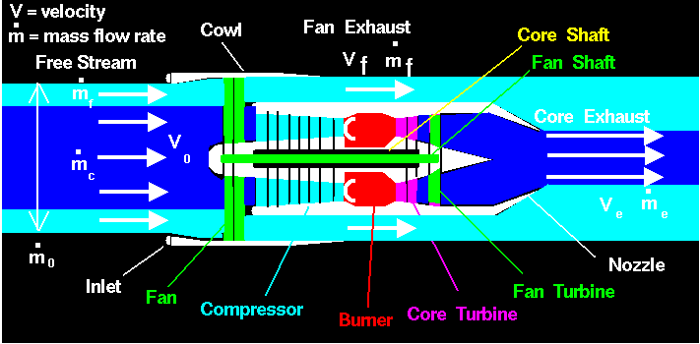

**Characteristics of a Turbofan Engine**

1. Increased thrust at forward speeds
2. Can fly beyond Mach 1
3. Weight falls between turbojet and Turboprop
4. Ground clearances are better than turboprop but not as good as turbojet
5. TSFC and specific weight falls between Turbojet and turboprop
6. Lesser noise level
7. Performance on a hot day is superior to the turbojet
8. Separate thrust reversers are required if Primary and fan air exit separately

**Advantages of Turbofan Engine**

* Short take off roll
* Comparatively quieter engine
* Weight per unit thrust is lower than turboprop engine
* Thrust is higher than turbojet engine

**Disadvantages of Turbofan Engine**

* Increased frontal area and drag
* Separate thrust reversers are required for hot and cold jets
* TSFC is higher than turboprop
* Engine is heavier and complicated than turbojet engine
* Lower speed limit (M<1) than turbojet engine

**RAMJET ENGINE**

A ramjet is engine is one of the simplest forms of Airbreathing engine, even simpler than the simplest turbojet engine. Ramjet engines use the forward motion of the aircraft to compress the incoming air i.e., it relies on the ram effect to increase the pressure of the incoming air. Ramjet engines are used on aircrafts operating between M=3 to M=6.

One of the major problems associated with a typical gas turbine engine operating between these speeds is the compression of air using a conventional axial flow compressor. The velocity of air in these speed regimes will be highly supersonic. An axial flow compressor will be unable to handle and operate at such high supersonic speeds due to the following reasons:

1. When a supersonic flow enters the compressor, due to its interaction with the compressor blades, shock waves will be formed at the blade tips giving rise to large pressure fluctuations. The resulting pressure fluctuations impose severe fatigue loads on the blades and this ultimately causes the blades to fail.
2. If the flow enters the compressor at supersonic velocities, the large kinetic energy of the air will cause the blades to heavily decelerate and slow down and the blades will eventually come to a standstill. Beside this there are also other problems like
3. The flow will never remain laminar but will become largely turbulent resulting in huge pressure losses –Rotational Flow
4. Internal shock reflections
5. High stage losses
6. Shock induced vibrations
7. Finally, to operate between M=3 to M=6, a compression ratio beyond 30 is required. But the maximum pressure ratio that can be developed with a conventional axial flow compressor is not more than 25. Hence, to achieve such pressure ratios, a conventional axial flow compressor becomes too inefficient and has to rely on some other technique to compress the incoming air. Hence, in such cases a ramjet engine just relies on the ram effect to produce very high pressure ratios. Since a ramjet engine operates at very high Mach numbers, the ram effect at high Mach numbers will be very significant. Due to the apparent ram effects at high forward velocities, the air gets compacted and compressed to very high pressures in the diffuser itself. Pressure ratios more than 30 can be achieved in the diffuser. As the required pressure ratios are achieved entirely in a diffuser, the compressor (and also the turbine) can be eliminated. Due to the absence of any rotating parts (Compressor and Turbine), a ramjet engine is considered to be simple compared to its counterparts. In fact the presence of such rotating parts like the compressors and turbine will cause more harm than favour, and hence Ramjets come without any of these parts.

**OPERATING PRINCIPLE OF RAMJET ENGINE**

Ramjet engines are the simplest form of air breathing engines consisting of following components:

* Supersonic Diffuser (1-2)
* Subsonic Diffuser (2-3)
* Combustion Chamber (3-4)
* Exhaust Nozzle(4-5)

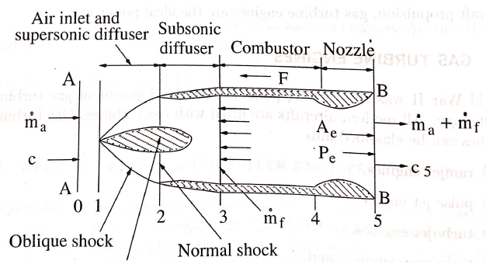

***Fig : Ramjet Engine operation***

The supersonic and subsonic diffusers help in converting the kinetic energy of the incoming air into pressure rise. This energy transformation is called as Ram effect. Usually, a ramjet engine operates at speeds greater than M=3. At these velocities, due to the configuration of the inlet diffuser, two different shock waves viz. ***oblique shock wave and a normal shock*** wave will be generated. The formed oblique shock wave will act as a supersonic diffuser and the normal shock wave will act as a subsonic diffuser.

During the operation of a ramjet engine, the atmospheric air enters the diffuser through the oblique shock wave as shown in the fig. As the air passes through the oblique shock wave, the flow will be heavily decelerated from high supersonic conditions to low supersonic conditions. Next, the low supersonic flow from the oblique shock wave will be passed through the normal shock wave. As it passes through the normal shock wave, the velocity of the air will be further decelerated from low supersonic Mach numbers to low subsonic Mach numbers. Thus by just passing the fluid through the shock waves, a required pressure ratio can be achieved. Later, this high pressure air will be made to pass through the combustion chamber, wherein it undergoes combustion. Finally, the generated exhaust gases will be expanded through the exhaust nozzle, thus creating the required forward thrust.

The greatest advantage of a ramjet engine is that, it is free from any rotating components like the compressor and the turbine. As the turbine is eliminated from the ramjet engine, very high thermal efficiencies can be obtained, thus increasing the performance of the engine. Besides, since a ramjet engine doesn't consist of a compressor, it cannot operate or take-off from static condition. In such cases the aircrafts/missile equipped with a ramjet engine has to be launched from an external launch vehicle or from an airplane in flight.

**CHARACTERISTICS OF RAMJET ENGINES**

The basic characteristics of a ramjet engine are as follows:

1. The construction of a ramjet engine very simple.
2. Mass production at relatively low cost
3. Independent of fuel technology and a wide range of fuels can be used. Liquid or solid fuels
4. Large fuel consumption at low and moderate speeds
5. Fuel consumption decreases with flight speed and approaches reasonable value when flight Mach number is between 2 and 5
6. Suitable for propelling supersonic missiles.

**Advantages of Ramjet engines**

* High combustion temperatures can be employed
* In the absence of rotating machinery, its construction is very simple, easy and economical
* It can operate efficiently at high supersonic Mach numbers
* It is not very sensitive to the quality of fuel (Usually hydrogen is used)
* It provides high thrust per unit weight and frontal area

**Disadvantages of Ramjet Engines**

* It requires a specialized launching device to take off
* It is not suitable for subsonic speeds
* It has low thermal efficiency and high TSFC
* Its maximum operating altitude is limited

**SCRAMJET (*Super Sonic Combustion Ramjet)***

**Scramjets** are designed to operate in the hypersonic flight regime, beyond the reach of turbojet engines. **Scramjet** engines operate on the same principles as ramjets do, but do not decelerate the flow of incoming air to subsonic velocities. Rather, a **scramjet**combustor is supersonic: the inlet decelerates the flow to a lower supersonic Mach number for combustion, after which it is accelerated to a higher Mach number through the nozzle.

The **scramjet**is composed of three basic components:

* A converging inlet, where incoming air is compressed and decelerated to lower supersonic velocities
* A combustor, where gaseous fuel is burned with atmospheric oxygen to produce heat energy
* A diverging nozzle, where the heated air is accelerated to produce thrust.

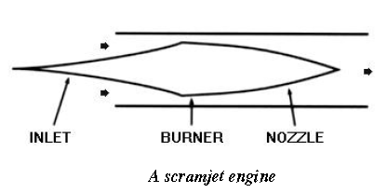

***Fig; Working of a Scramjet engine***

Air from the atmosphere enters the supersonic diffuser where its velocity is reduced to lower supersonic speeds and pressure is increased. This high pressure supersonic air is then passed into the combustion chamber. In the combustion chamber the fuel injection system sprays a fine stream of fuel droplets which is mixed with the compressed air. This mixture then flows through the chamber containing flame holders to stabilize the flame. The mixture is then ignited through means of igniter plugs and undergoes combustion. Combustion raises the temperature of the mixture to the order of 1500-2000K by continuous supply and combustion of fuel. The hot gases are then made to expand in the combustion chamber towards the tail pipe. Further, they are allowed to expand through the nozzle and are expelled out at a very high velocity thus producing thrust. The products of combustion will leave the engine with a speed exceeding that of the incoming air. Due to the rate of increase in the momentum of the working fluid, a thrust F is developed in the direction of the flight. The materials presently used for the walls of the combustion chamber and nozzles cannot tolerate temperatures above 2000 degrees, but they can be kept much cooler than the main fluid stream by a fuel injection pattern which leaves a shielding layer of relatively cool air adjacent to the walls.